CS2022 Computer Architecture: Project 1B

Contents

Register File 1

Function Unit 2

ALU 2

Arithmetic Circuit 2

Logic Circuit 5

Shifter 5

Data Path 6

Multiplexers 7

Ellen Whelan 17324116

# Register File

I altered the register file from the previous assignment (added second mux and B data bus etc) and rewrote the test bench accordingly.

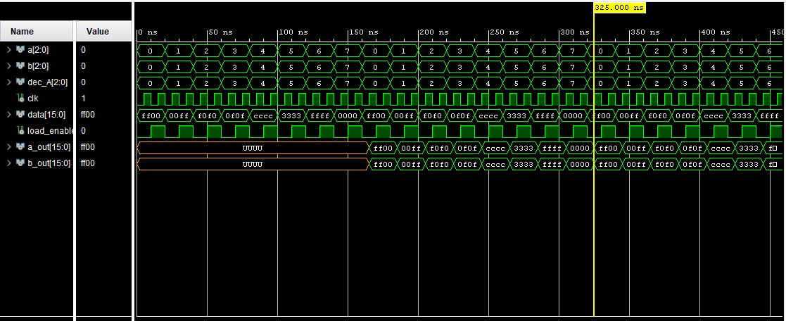

To test the reg file I loaded different data into each register one by one and then set a out and b out to show that data in each register one by one. The a out signal and b out are undefined in the first iteration of the test bench as they are accessing empty registers.

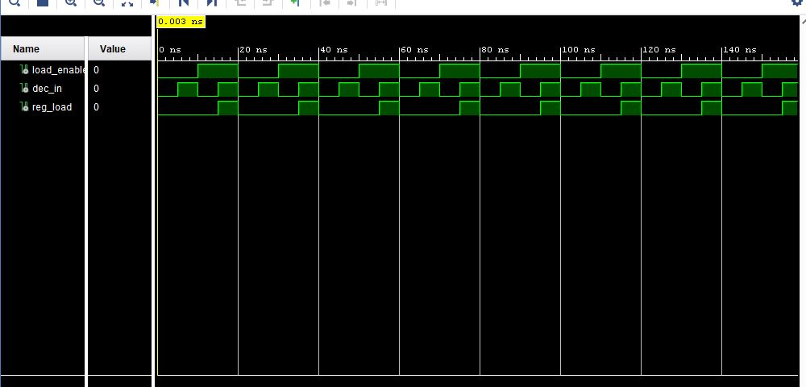Also in the register file I created and gates and tested them by using the following table.

|  |  |  |
| --- | --- | --- |
| Input | Load Enable | Output |
| 0 | 0 | 0 |
| 0 | 1 | 0 |
| 1 | 0 | 0 |
| 1 | 1 | 1 |

# Function Unit

The function unit contains the ALU and the shifter

## ALU

The ALU contains an arithmetic circuit and a logic circuit

### Arithmetic Circuit

The ALU contains an arithmetic circuit and a logic circuit. The arithmetic circuit contains B_input_logic and the ripple adder.

#### B_input_logic

I tested the B input logic by iterating through all the combinations of S0 and S1.

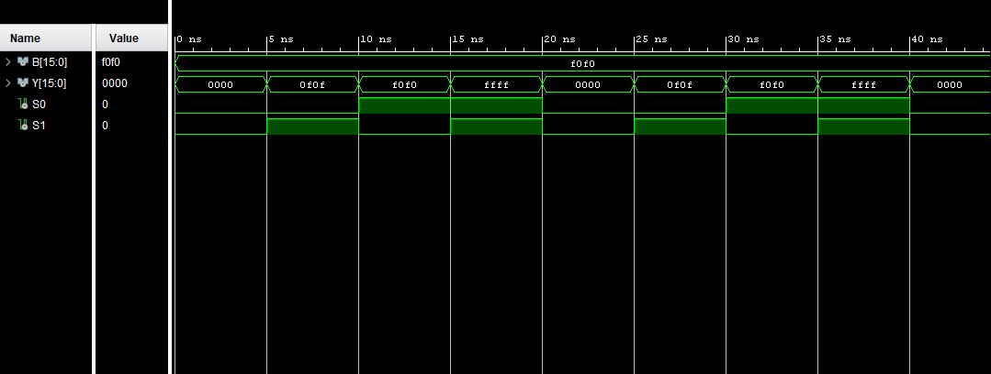

#### Parallel Adder

Testing the Full Adder

I first wrote and tested a half adder. To test it fully I iterated through all the combinations of X and Y 00,01,10,11, to show the table:

|  |  |  |  |
| --- | --- | --- | --- |
| X | Y | Sum | Carry |
| 0 | 0 | 0 | 0 |
| 0 | 1 | 1 | 0 |
| 1 | 0 | 1 | 0 |
| 1 | 1 | 1 | 1 |

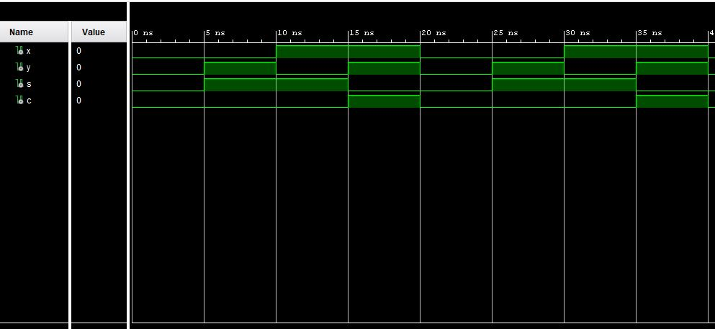

Then I instantiated a half adder twice to make a full adder. I then write the test bench to run through all the possible combinations of inputs x,y and z (000 to 111)

to ensure the correct answer was produced and the correct carry.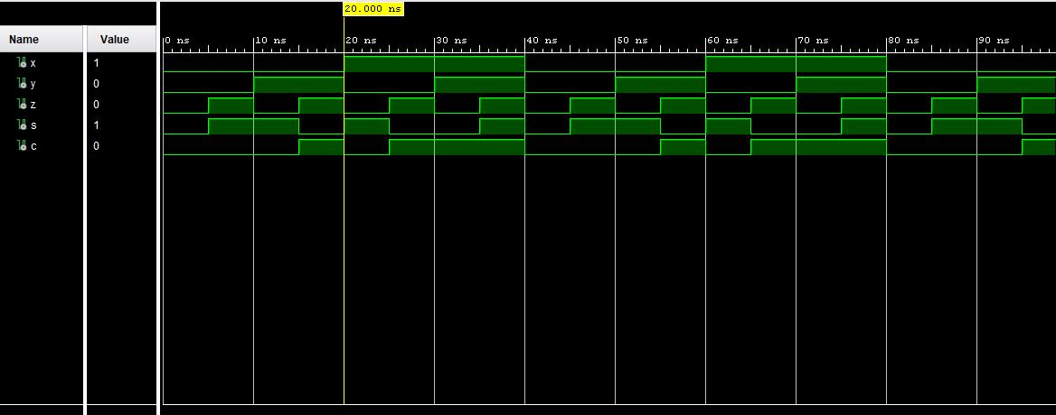

Finally I instantiated the full adder 16 times and made the ripple adder. In the test bench I simulated signals to show that carry and overflow were set when needed and not when not. I showed that the sum value was correct with both a carry in of 0 and 1.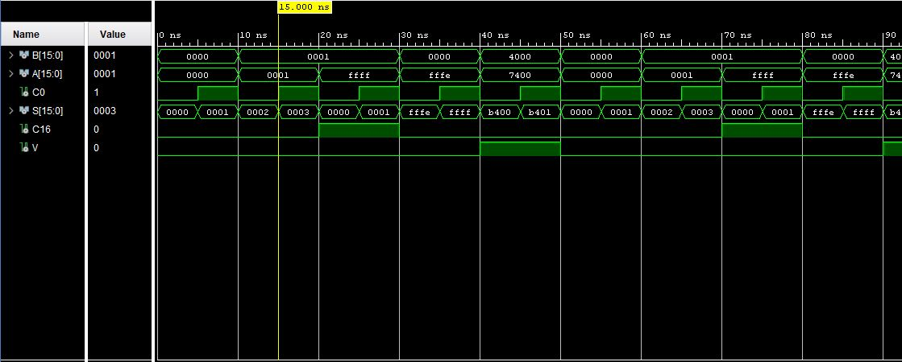

I tested the entire arithmetic circuit by testing each combination of S0 and S1 with a cin of 0 and 1.

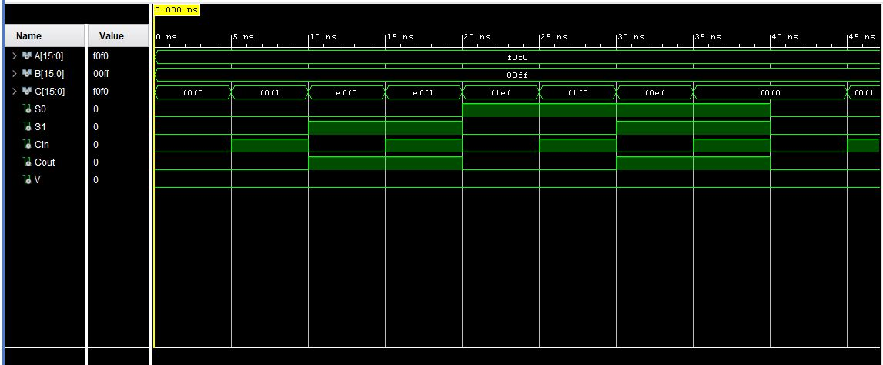

### Logic Circuit

To test the logic circuit I iterated through all the combinations of S0 and S1 to get all the possible logical operations to occur on the values in A and B.

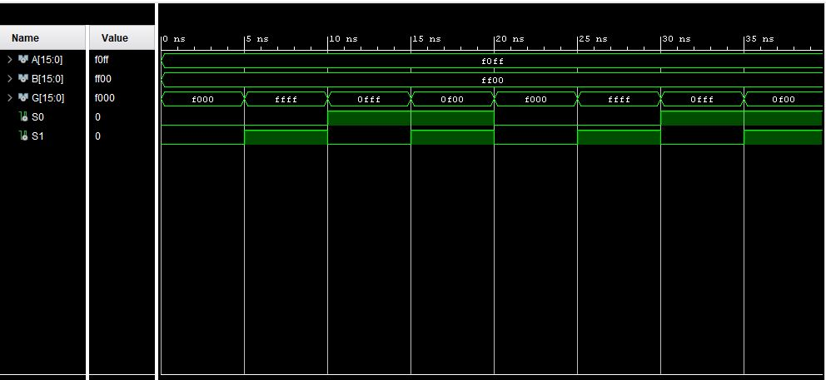

I tested the entire ALU by iterating through all the g_sel options to ensure each operation carries out correctly.

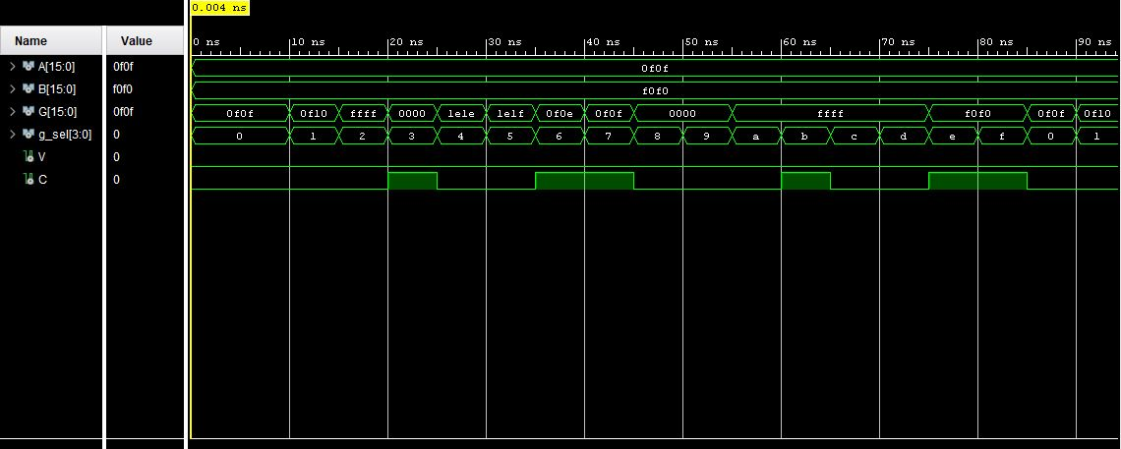

## Shifter

I tested both shifting right and shifting left, and transferring by testing both h_sel options.

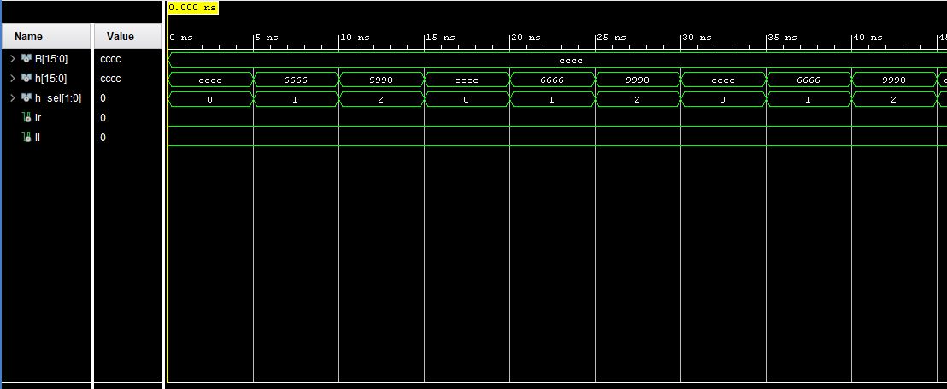

I tested the entire function unit by iterating through all the fs options to ensure the correct operation occurred and the correct output was generated.

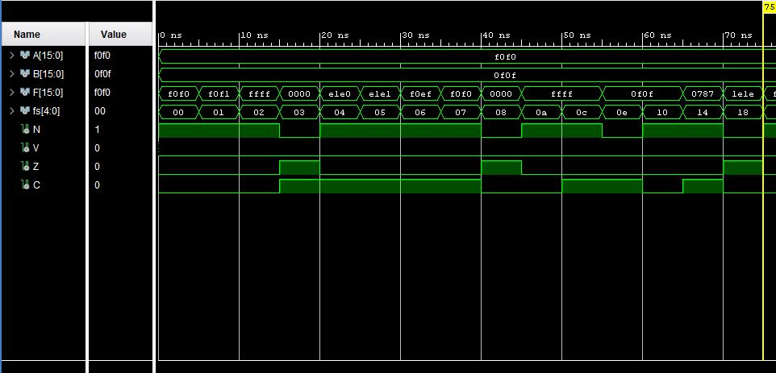

# Data Path

The data path contains the function unit and the register file. I tested the entire data path by testing that the result of the operation is stored where I declare it and the output comes from the register I declare in the control word. I didn’t test all the operations again as they are thoroughly tested in previous test benches. Instead I focused on ensuring the data loads to and from where I declare in the control word when the load enable is 1.

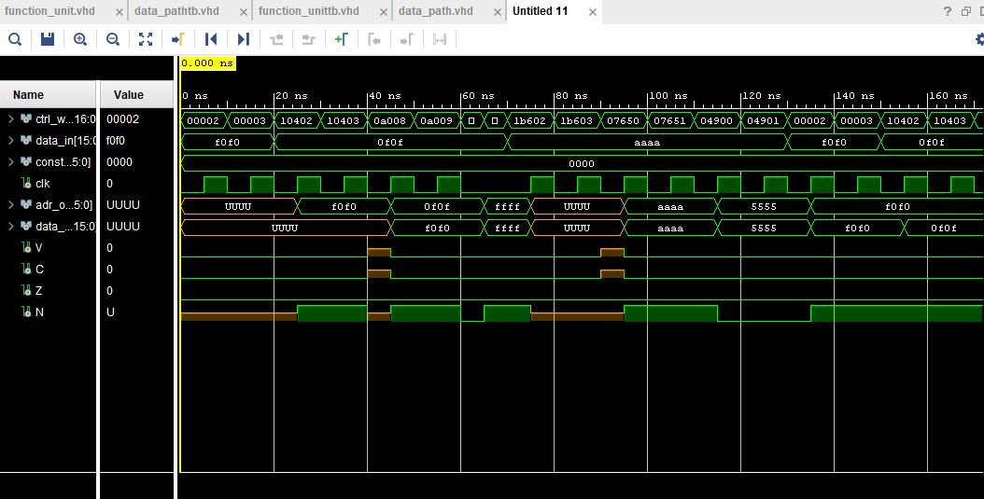

# Multiplexers

In this section of the project I added two more multiplexer types the multiplexers already created and tested in the previous part. The first one added was the mux2_1.

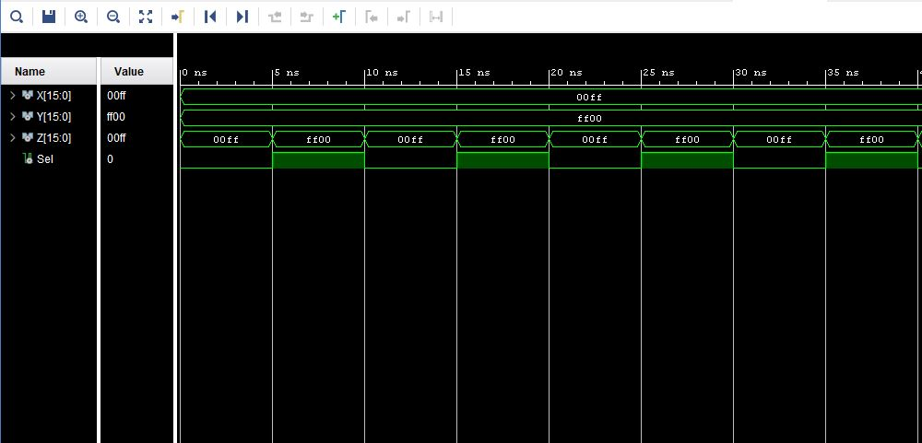I iterated through combinations of X Y with select changing from 0 to 1.

Mux3_1 I also had to create a multiplexer with 3 inputs and 1 output.

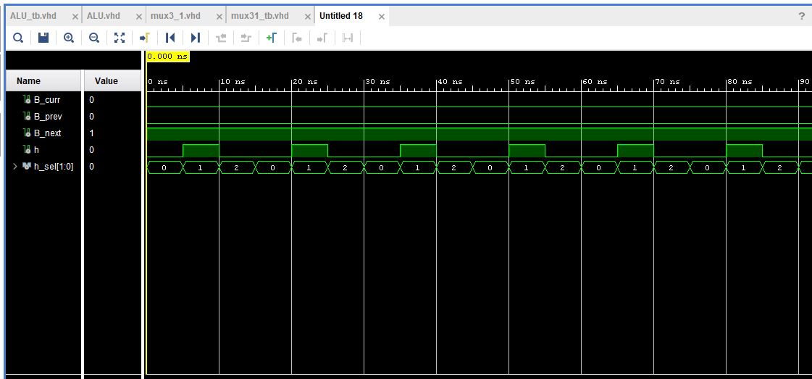Again I tested with 2 bit select alternating from 0 1 and 2.